Design of IOT Architecture for Battery Charging Management System

Dr. Sujith kalluri Ph.D _ ECE
SRM University, Andhra Pradesh, India
sujith.k@srmap.edu.in

Mr. Jagadeeswara Chandra bose. K M.Tech _ ECE
SRM University, Andhra Pradesh, India
Jagadeeswara_kamarajugadda@srmap.edu.in

Abstract - This research proposes a novel IoT-based architecture for electric vehicle (EV) battery charging management, addressing the critical demand for scalable and sustainable charging infrastructure. The system integrates solar energy, energy storage systems (ESS), and grid power through a Point of Common Coupling (PCC), optimizing energy distribution via a five-layer IoT architecture: Sensor, Microcontroller & Data Acquisition, Communication, Cloud Server, and User Interface layers. Real-time monitoring, predictive analytics, and automated decision-making enhance operational efficiency, achieving 88.6% energy-saving efficiency (1,608 kW/day from renewables) and 88.5% cost-saving efficiency (₹19,296/day savings). The architecture supports battery swapping stations and DC fast charging, generating ₹26,986/day in revenue while stabilizing grid loads. This work bridges gaps in EV infrastructure standardization and economic viability, offering a scalable solution for smart cities and industrial applications.

Keywords: IoT Architecture, Renewable Energy Integration, Battery Swapping, Smart Grid, Predictive Analytics, Energy Storage Systems, Real-time Monitoring.

- Introduction
The rapid growth of electric vehicles (EVs) has highlighted the critical need for an efficient and robust charging infrastructure. As the global shift towards sustainable transportation accelerates, the demand for innovative charging solutions has become increasing rapidly. This research focuses on developing an Internet of Things (IoT) architecture specifically designed for battery charging management, which integrates renewable energy sources such as solar power and energy storage systems (ESS) with grid power.

The proposed architecture comprises five layers are Sensor Layer, Microcontroller & Data Acquisition Layer, Communication Layer, Cloud Server & Data Storage, User Interface Application Layer. This multi-layered IoT architecture enables real-time data monitoring and analytics, optimizing power demand management and boosting operational efficiency in EV charging systems. Initial simulations demonstrate 88.5% operational cost reduction through resource optimization, addressing critical challenges such as the absence of standardized charging protocols and limited research on the economic feasibility of grid-to-vehicle technology. By integrating solar, ESS, and grid power at the Point of Common Coupling (PCC) Fig. 1, the system supports remote monitoring and dynamic energy distribution.

This work advances sustainably transportation by harmonizing renewable energy utilization, grid stability, and scalable infrastructure design, paving the way for smarter energy management solutions in future smart cities.
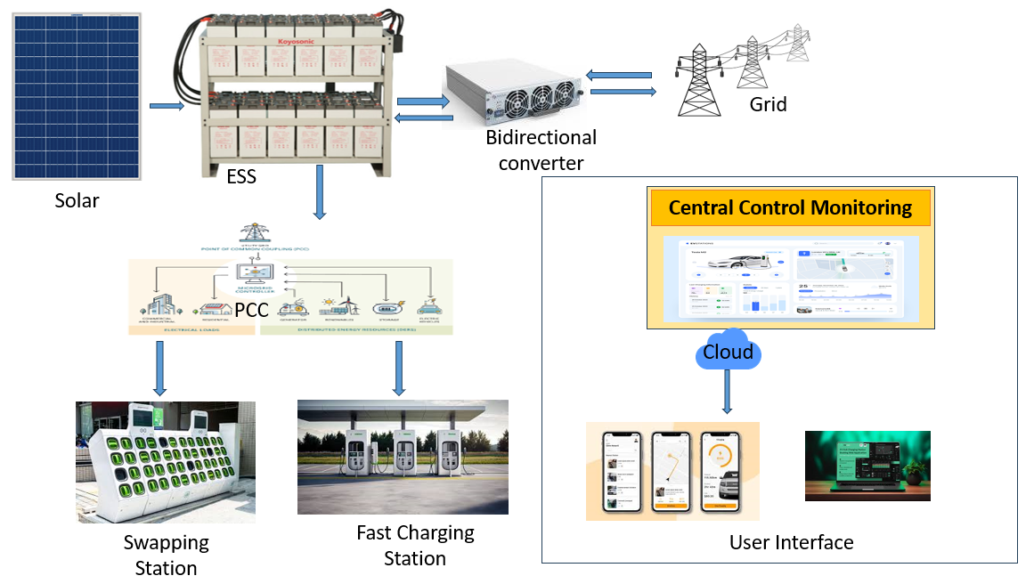
Fig 1: Integration of power sources and loads with PCC

Battery swapping and DC fast charging are critical to a robust EV ecosystem. Integrated with IoT, these technologies leverage real-time data and predictive analytics to optimize energy use, boost efficiency, and promote sustainability, aligning with smart city and renewable energy goals.

DC fast charging addresses range anxiety by delivering an 80% charge via high-voltage direct current, bypassing onboard chargers. Strategic deployment along highways and urban hubs ensures scalability, supporting EV adoption and grid stability.

The rest of the paper is outlined as follows: Section 2 Literature survey; Methodology in detailed in section 3. While section 4 contains its solution methodology. MATLAB Simulation and results are discussed in section 5. Finally, the paper is concluded in section 6.

- Literature Survey
The integration of IoT and renewable energy into EV charging infrastructure has been extensively explored to address grid stability, energy efficiency, and user convenience. Studies such as Solar monitoring ([1], [2]) and ESS optimization ([3], [14]) address energy harvesting and storage. Battery swapping logistics ([7]– [9]) mitigate grid strain through optimized station planning and mobile units. IoT-driven solutions ([4]– [6], [10]– [13], [16]) enhance microgrid operations, fault detection, and sensor placement, while residential charging studies ([11], [12]) tackle accessibility and scheduling. Power quality ([6], [15]) and safety innovations ([15], [16]) prioritize grid reliability and battery management. Despite advancements, gaps persist in hybrid system standardization (solar/ESS/grid at PCC) and economic viability. This work bridges these gaps by unifying IoT, predictive analytics, and dynamic energy distribution ([10], [12]), advancing scalable and cost-efficient EV infrastructure.
- Methodology

The proposed IoT architecture integrates solar energy, energy storage systems (ESS), and grid power at the Point of Common Coupling (PCC), prioritizing renewable energy utilization. Solar power charges the ESS and powers loads; excess energy (ESS >80%) is fed back to the grid via a bidirectional converter. During low/no sunlight, ESS discharges (down to 20% SOC) before switching to grid power. The system supports a battery swapping station (30 batteries) and four DC fast charging stations, with real-time sensor data transmitted to a cloud-based dashboard for monitoring. Predictive analytics optimize power demand, validated through MATLAB and Node-RED simulations, ensuring dynamic load adjustments and grid stability. This scalable framework enhances operational efficiency, achieving 88.5% cost savings by minimizing grid dependency, and promotes a sustainable EV ecosystem Fig. 2.

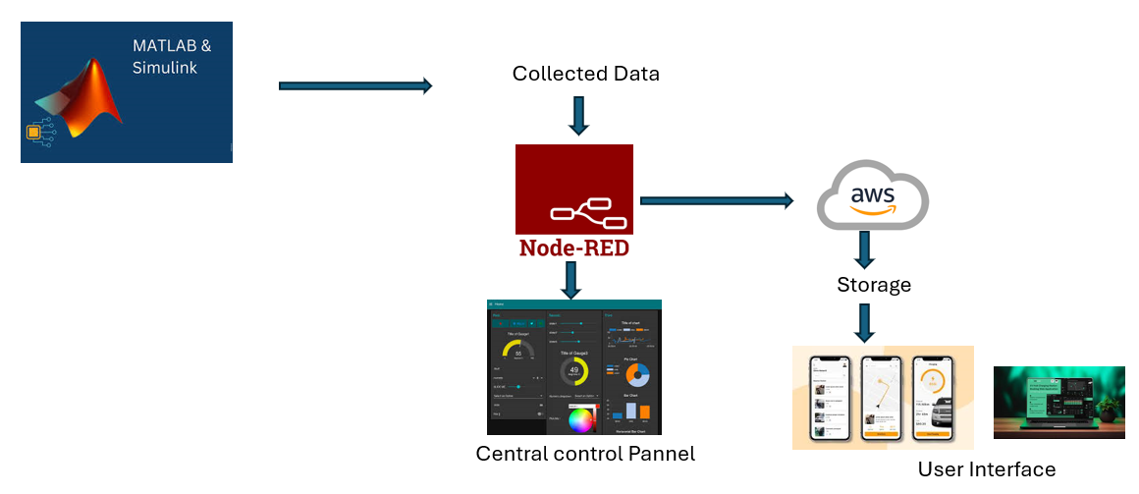
Fig 2: Flow of Methodology

- Proposed Design and Architecture.
- IOT Architecture
The five-layer architecture proposed for the IoT framework in battery charging management technology is designed to enhance the efficiency and effectiveness of electric vehicle (EV) charging infrastructure. Each layer serves a specific function that collectively contributes to the overall system's performance. The proposed IOT Architecture show in fig 3.
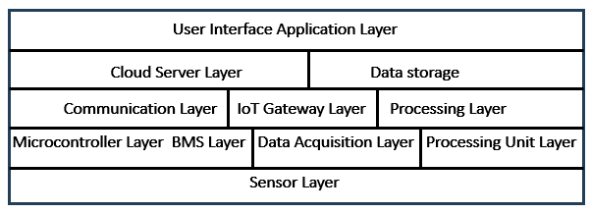
Fig 3: Five-layer IOT architecture
Sensor Layer: Collects real-time charging status, energy levels, and environmental data to optimize operations.
Microcontroller Layer: Processes sensor data to monitor performance and efficiency metrics.
Communication Layer: Ensures seamless, reliable data transmission between IoT devices.
Cloud Layer: Manages secure data storage and enables remote analytics for decision-making.
UI Layer: Provides real-time monitoring of charging metrics via an intuitive user interface.
This architecture employs real-time analytics to optimize power demand and battery efficiency while integrating solar, ESS, and grid power at the PCC. It addresses grid strain, enhances sustainability, and streamlines EV charging operations.

- Power Flow logic conditions
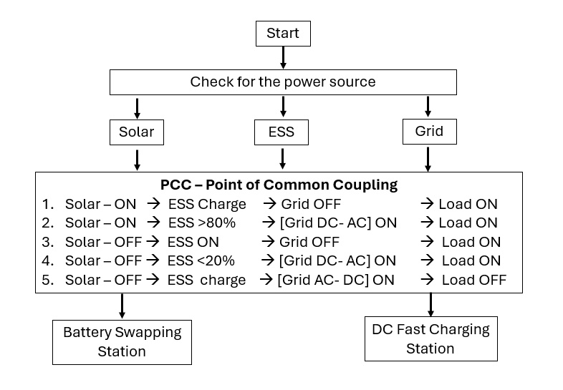
Fig 4: outlines the logic for managing the charging of batteries
This flowchart outlines the logic for managing the charging of batteries in a system shows in fig 4 that integrates multiple power sources: solar, energy storage systems (ESS), and the grid. The system aims to optimize battery charging by prioritizing renewable energy sources and utilizing the grid when necessary.
The system prioritizes renewable energy sources (solar and ESS) to optimize battery charging, minimizing grid dependency. Initially, solar power charges the battery directly if available. When solar is active, ESS charging occurs only if its state of charge (SOC) is below 80%, with the grid disabled; if ESS exceeds 80%, solar powers the load directly while the grid provides backup. During solar unavailability, ESS powers the load if its SOC is above 20%. If ESS drops below 20%, the grid activates to ensure uninterrupted power supply. When Charging is ideal then only ESS will charge again from the grid. This threshold-driven hierarchy (solar → ESS → grid) ensures efficient renewable utilization, seamless transitions between sources, and grid stability, addressing both operational efficiency and sustainability goals.
- PCC Integration and Automation
This flowchart outlines the logic for integrating a Point of Common Coupling (PCC) with various power sources (solar, ESS, and grid) to optimize energy flow and manage battery charging shown in fig 5.
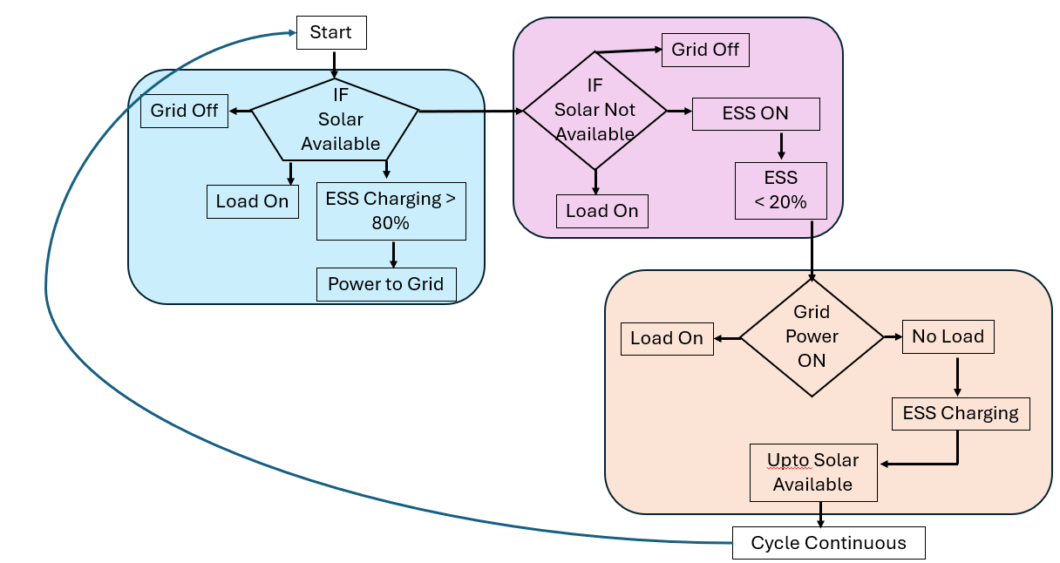
Fig 5: PCC Integration and Automation
The system automates energy flow at the Point of Common Coupling (PCC), prioritizing solar power to charge the ESS until it reaches 80% SOC, after which excess solar feeds into the grid. During solar unavailability, ESS powers the load until its SOC drops below 20%, triggering grid activation. Under grid reliance, ESS recharges during low-load intervals. This threshold-driven cycle ensures renewable optimization, minimizes grid dependency, and sustains uninterrupted power through dynamic, real-time adjustments.
- Algorithms
The proposed algorithms within the IoT architecture for battery charging management are essential for optimizing the charging operations of electric vehicles (EVs) while integrating renewable energy sources such as solar power and Energy Storage Systems (ESS) with grid electricity.
SOC Calculation: The battery state of charge via voltage, current and temperature readings and thresholds, preventing overcharging/deep discharge to battery health.
Charging/Discharging Control: Manages energy flow based on SOC thresholds (e.g., charges if SOC <40%, prioritizes load if SOC >80%).
MPPT: Maximizes solar harvest by dynamically adjusting duty cycles using real-time voltage/current data under varying conditions.
Predictive Analytics: Collects sensor data (voltage, current, temperature) to forecast energy demand and optimize resource allocation.
Energy Source Management: Prioritizes solar → ESS → grid, ensuring optimal use of renewables and grid fallback during deficits.

- Designed MATLAB Simulations
The MATLAB simulation integrates solar, ESS, and grid power at the PCC, prioritizing energy flow as solar → ESS → grid to optimize EV charging. Real-time dynamic management ensures efficient resource utilization, while connected battery swapping stations and fast charging units enable flexible energy distribution, adapting to fluctuating demand.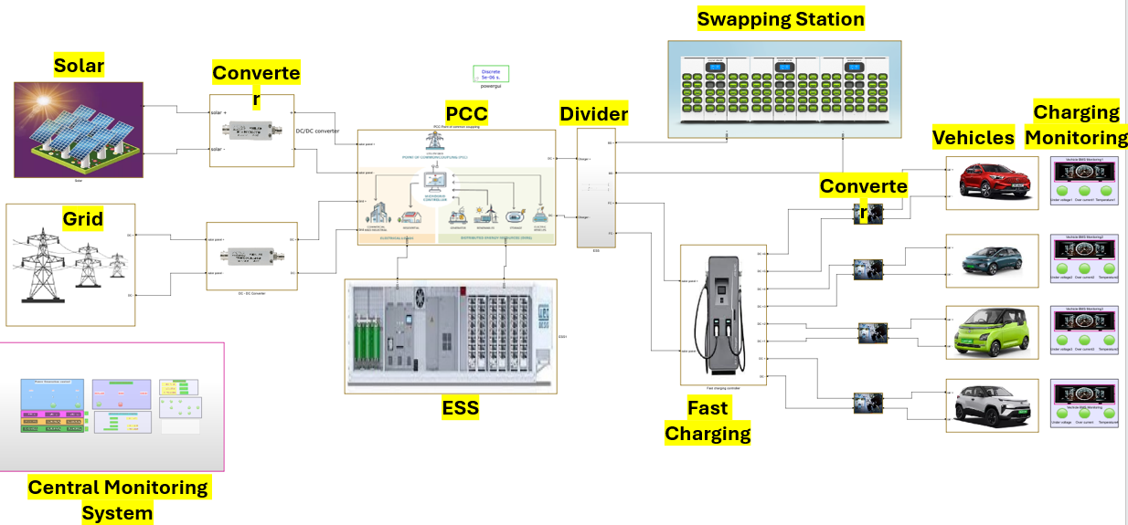
Fig 6: The Simulation of Designed Battery Charging system

The simulation integrates solar, ESS, and grid power at the PCC, dynamically managing energy flows to optimize EV charging. A five-layer IoT architecture (Sensor, Microcontroller, Communication, Cloud, User Interface) monitors battery parameters (voltage, current, SOC, temperature) in real time, enabling proactive charging management and battery health optimization. This centralized framework adapts to energy fluctuations while allowing users to track charging status and consumption efficiently.
a) Solar Energy
Solar serves as the primary renewable source, powering charging stations during peak sunlight. Solar panels reduce grid dependency and operational costs while minimizing carbon emissions and enhancing charging efficiency.
b) Energy Storage System (ESS)
ESS stores excess solar energy, ensuring reliable power during low generation. It optimizes renewable utilization, supports peak demand, and strengthens infrastructure resilience.
c) Grid Power
Grid acts as a backup during solar/ESS deficits. PCC automation enables seamless transitions between sources, prioritizing solar and feeding excess energy (ESS >80%) back to the grid.

d) PCC Integration (Fig. 7)
The PCC integrates solar, ESS, and grid for dynamic energy management. Solar powers loads and charges ESS; ESS discharges during solar shortages (down to 20% SOC). Grid activates only when renewables are insufficient, ensuring sustainability, cost reduction, and uninterrupted operations.
Fig 7: Integrated and Automation PCC control
Automation at the PCC prioritizes solar energy and redirects excess ESS power (>80% SOC) to the grid. During solar deficits or ESS depletion (<20% SOC), grid power activates. An IoT framework monitors real-time parameters (voltage, current, SOC, temperature) to ensure battery health and proactive charging management. Predictive analytics optimize energy demand forecasts and charging schedules using historical and real-time data, enhancing efficiency and grid stability.
- Battery Swapping Station.
Battery swapping stations (Fig. 8) enhance EV infrastructure efficiency by enabling rapid battery replacement (minutes vs. traditional charging), minimizing downtime and alleviating range anxiety. The system integrates 30 lithium-ion batteries (12V, 10A) at the PCC, supporting sustainable transportation. Particularly beneficial for commercial fleets and ride-sharing services, it ensures quick turnaround times and reliable energy distribution, optimizing operational workflows and user convenience.
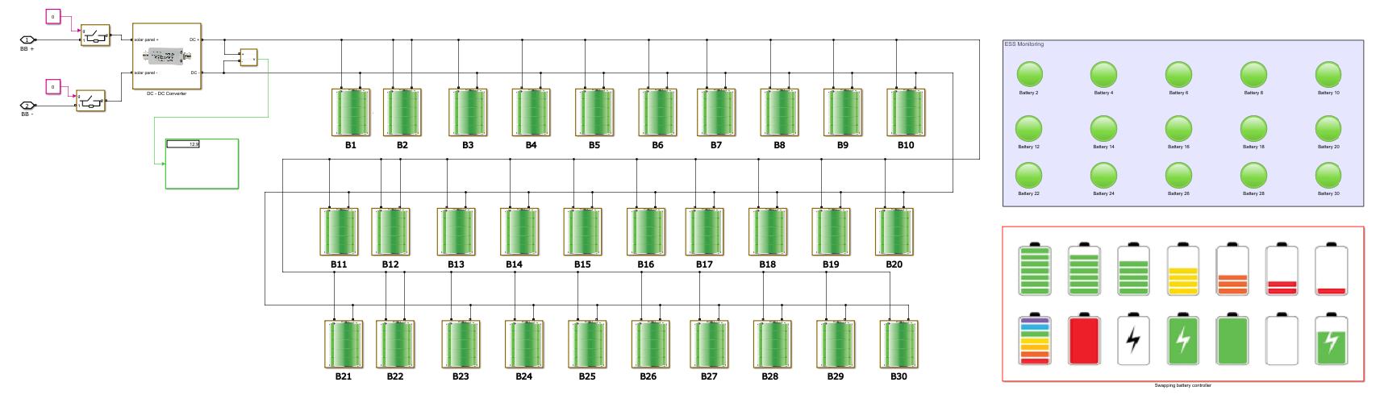
Fig 8: Battery Swapping Station Simulation.

The Centralized battery management in swapping stations monitors SOC, temperature, and performance to ensure optimal battery health and longevity, deploying only well-conditioned units to vehicles. Strategically located near renewable sources (e.g., solar at PCC), these stations store excess solar energy in batteries during peak generation, reducing grid reliance and advancing sustainability.

- DC Fast charging station
DC fast charging stations (Fig. 9) are pivotal in EV infrastructure, using direct current (DC) to deliver high-power charging, reducing time to 80% battery capacity in ~30 minutes—critical for fleet operators and long-distance travel. By outperforming traditional AC methods, these stations alleviate range anxiety, accelerate EV adoption, and advance sustainable transportation ecosystems.
Fig 9: DC Fast Charging Station.

The system integrates DC fast charging with solar and ESS, utilizing excess solar energy to prioritize sustainability and reduce grid dependency. These high-power stations support commercial/public networks, enabling simultaneous multi-vehicle charging to meet urban and major travel route demands efficiently.

- Data Monitoring and Cloud Connectivity.
- Node-Red Connectivity and Dashboard monitoring
The IoT architecture integrates MATLAB with ThingSpeak (cloud analytics) and Node-RED for real-time data monitoring and visualization. MATLAB processes power metrics (voltage, current, SOC, solar/ESS/grid outputs) from charging stations, while ThingSpeak stores and analyzes time-series data for trend visualization. Node-RED generates interactive dashboards to display charging status and energy consumption, enabling alerts for anomalies (e.g., low SOC) or solar overproduction. This framework enhances decision-making, user engagement, and proactive management through seamless data flow: MATLAB → ThingSpeak → Node-RED.
Fig 10: Node-Red Simulation

The IoT architecture streamlines data flow from MATLAB (data processing) to ThingSpeak (cloud analytics) and Node-RED (visualization/automation), enhancing operational efficiency through optimized energy use and real-time analytics (Fig. 10). By maximizing renewable energy utilization and enabling proactive decisions, this integration ensures reliable EV charging services, advancing sustainable transportation ecosystems.

Fig 11: Dashboard Visualization
The system integrates sensor and operational data into visual dashboards, enabling users to track charging station performance, analyze energy consumption trends, and monitor battery swapping/fast charging unit status. These dashboards provide intuitive access to critical data, enhancing user engagement and empowering operators to make rapid, informed decisions.

- AWS cloud Connectivity
Amazon Web Services (AWS) enhances system reliability through Amazon S3 for scalable, secure storage of solar, ESS, grid, and battery swapping data, enabling historical performance analysis. Amazon SNS automates email alerts for anomalies (e.g., ESS SOC < threshold, energy deviations), ensuring timely interventions to maintain efficiency. This AWS integration streamlines data management, supports proactive maintenance, and optimizes operational workflows.

Fig 11. AWS Flow
- Amazon QuickSight enables interactive dashboard creation from S3-stored data, visualizing KPIs such as energy production trends and charging efficiency metrics. Custom dashboards provide real-time analytics for effective system monitoring, empowering stakeholders to make data-driven decisions.

- Results Energy and Cost Efficiency
The project results indicate significant energy and cost efficiency achieved through the integration of solar energy, Energy Storage Systems (ESS), and grid power in the battery charging management system. Daily power generation is distributed as follows: 60% from solar energy, 40% from ESS, and 10% from the grid, leading to an impressive overall energy efficiency of 88.5%.

Fig 12. Energy estimation graph

In terms of cost, the system charges customers 10 rupees per unit for fast charging and 50 rupees per battery swap. The utilization of grid power incurs a cost of 12 rupees per unit on the energy bill. Notably, the project has demonstrated a year-on-year profit increase of 40-60%, showcasing the economic viability of this integrated approach to EV charging infrastructure. This combination of renewable energy sources and efficient operational practices not only enhances sustainability but also contributes to a profitable business model in the rapidly growing electric vehicle market.

Fig 12. Cost estimation Graph

- Conclusion

This IoT architecture for battery charging management not only meets the immediate challenges posed by the growing demand for EV infrastructure but also promotes sustainable practices through effective utilization of renewable energy sources. Future developments will focus on refining this architecture and expanding its capabilities to further enhance energy management in electric vehicle applications. By leveraging real-time data analytics and centralized monitoring, this project positions itself as a forward-thinking solution in the rapidly evolving landscape of electric vehicle infrastructure, ultimately contributing to a greener transportation ecosystem.

XI. Reference
- Cheng-Ta Chiang; Liang-Yu Chien “A Pitaya Dye-Sensitized Solar Cell Monitor for Environmental Sunlight Intensity Detection” IEEE Sensors Journal, 19-11, 03 February 2019.
- Saswat Kumar Ram; Sauvagya Ranjan Sahoo; Banee Bandana Das; Kamalakanta Mahapatra; Saraju P. Mohanty
“Eternal-Thing: A Secure Aging-Aware Solar-Energy Harvester Thing for Sustainable IoT” IEEE Transactions on Sustainable Computing, 6-2, 15 April 2020.
- Tai-Yeon Ku; Wan-Ki Park; Hoon Choi “ESS Simulation based on PV Generation Prediction” 2018 International Conference on Information and Communication Technology Convergence (ICTC), 18 November 2018.
- Abdelrahman Ahmed; Sobhy Abdelkader; Ehab Ayman “IoT-based optimization of microgrid operation” 2023 24th International Middle East Power System Conference (MEPCON), 18 March 2024.
- George Y. Odongo; Richard Musabe; Damien Hanyurwimfura; Abubakar Diwani Bakari “An Efficient LoRa-Enabled Smart Fault Detection and Monitoring Platform for the Power Distribution System Using Self-Powered IoT Devices” IEEE Access (Volume: 10), 07 July 2022.
- Isa Hafidz; Ardyono Priyadi; Margo Pujiantara; Dimas Okky Anggriawan; Mauridhi Hery Purnomo “Development of IoT-Based Portable Power Quality Monitoring on Microgrids by Enhancing Protection Features” IEEE Access (Volume: 11), 15 May 2023.
- Dan Zheng; Fushuan Wen; Jiansheng Huang “Optimal planning of battery swap stations” International Conference on Sustainable Power Generation and Supply (SUPERGEN 2012), 04 April 2013.
- Bansilal Bairwa; Mrinal Sarvagya; Sanjeeva Kumar; Arpita Banik “Battery Swapping Mobile Service Station for Electric Vehicles Application” 2021 Second International Conference on Smart Technologies in Computing, Electrical and Electronics (ICSTCEE), 15 February 2022.
- Xian Zhang; Guibin Wang “Optimal dispatch of electric vehicle batteries between battery swapping stations and charging stations” 2016 IEEE Power and Energy Society General Meeting (PESGM), 14 November 2016.
- Sayantika Sikdar; Madhavi Damle “IoT Solutions for Electric Vehicles (EV) Charging Stations: A Driving Force Towards EV Mass Adoption” 2022 International Interdisciplinary Humanitarian Conference for Sustainability (IIHC), 17 March 2023.
- Ashutosh Vijay Panchbhai; Ramakrishnan Raman; Chintan Bhupeshbhai Thacker; S. Muthumarilakshmi; S. Murugan “Residential Electric Vehicle Charging Station Using the Internet of Things” 2023 International Conference on Power Energy, Environment & Intelligent Control (PEEIC), 13 March 2024.
- S. Arulmozhi; M. Abiramavalli; M.B.Diviya Bhavaani; S. Loganayagi “IoT enabled E-Vehicle Charging System with Battery Monitoring and Charge Scheduling” 2023 First International Conference on Cyber Physical Systems, Power Electronics and Electric Vehicles (ICPEEV), 19 January 2024.
- Joe-Air Jiang; Jen-Cheng Wang; Hung-Shuo Wu; Chien-Hsing Lee; Cheng-Ying Chou; Li-Cheng Wu “A Novel Sensor Placement Strategy for an IoT-Based Power Grid Monitoring System” IEEE Internet of Things Journal, 7-8, 30 April 2020.
- Enrique A. Sanabria-Torres; Adriana C. Luna; Nelson L. Diaz; Fabio Andrade-Rengifo “State-of-Charge Equalizations Comparison in a Multi-prosumer Environment Based on Real-Time Energy Management Systems with IoT-Support” 2023 IEEE Applied Power Electronics Conference and Exposition (APEC), 31 May 2023.
- Santosh Kumar Tripathi; Swati Maurya; Aditi Dubey; Prakhar Pal; Aparna Tiwari “IoT Based Electrical Vehicle Battery Management System with Charge Monitor and Fire Protection” 2024 3rd International conference on Power Electronics and IoT Applications in Renewable Energy and its Control (PARC), 04 April 2024.
- Mersin, Türkiye “An IoT -based Power Management System for EV Chargers” 6th Advanced Engineering Days (AED), 5 March 2023.

